Develop A Web Application Using Node-RED

|  |  |
| --- | --- |
| Date | 02 November 2022; |
| Team ID | PNT2022TMID50962 |
| Project Name | Project - IoT Based Safety Gadget For Child Safety Monitoring & Notification |
| Maximum Marks | 2 Marks |

Steps Followed:

* 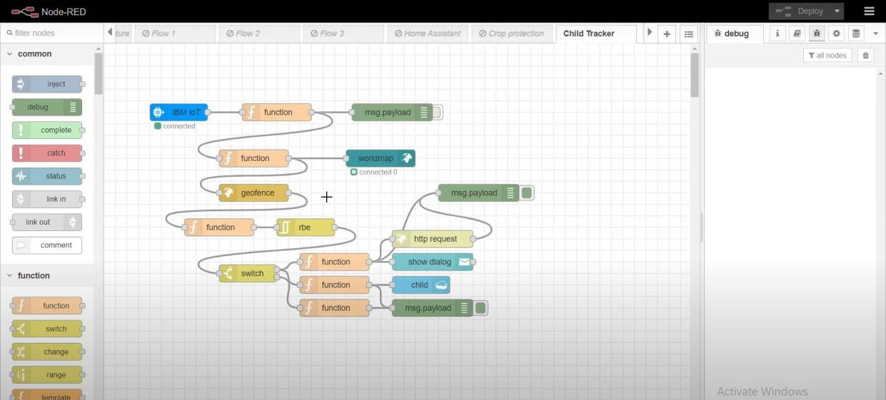Opened a Node-RED project
* 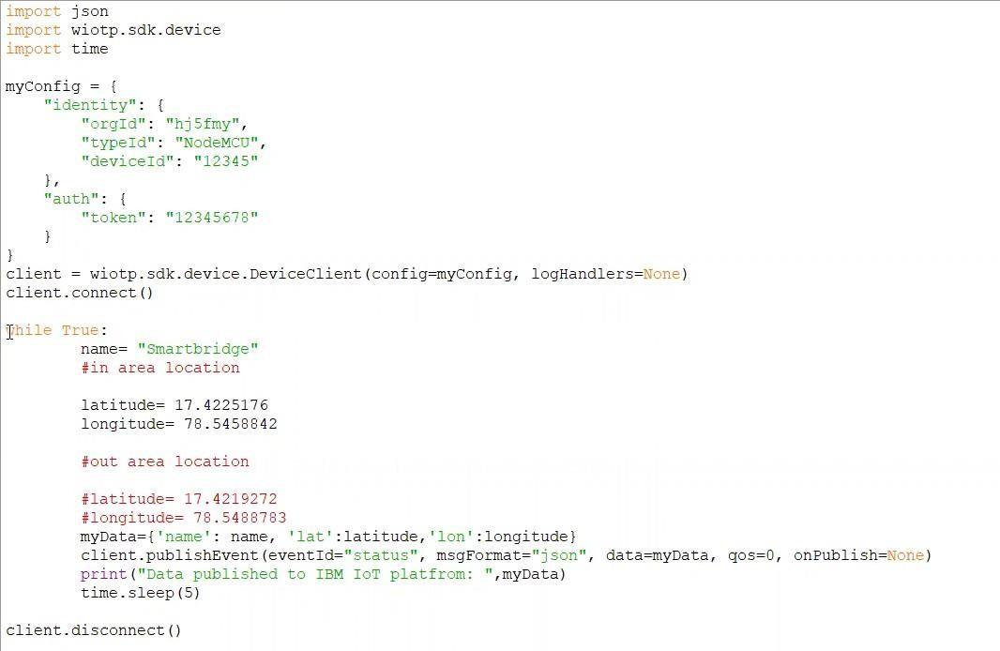Added code to get child location in python
* 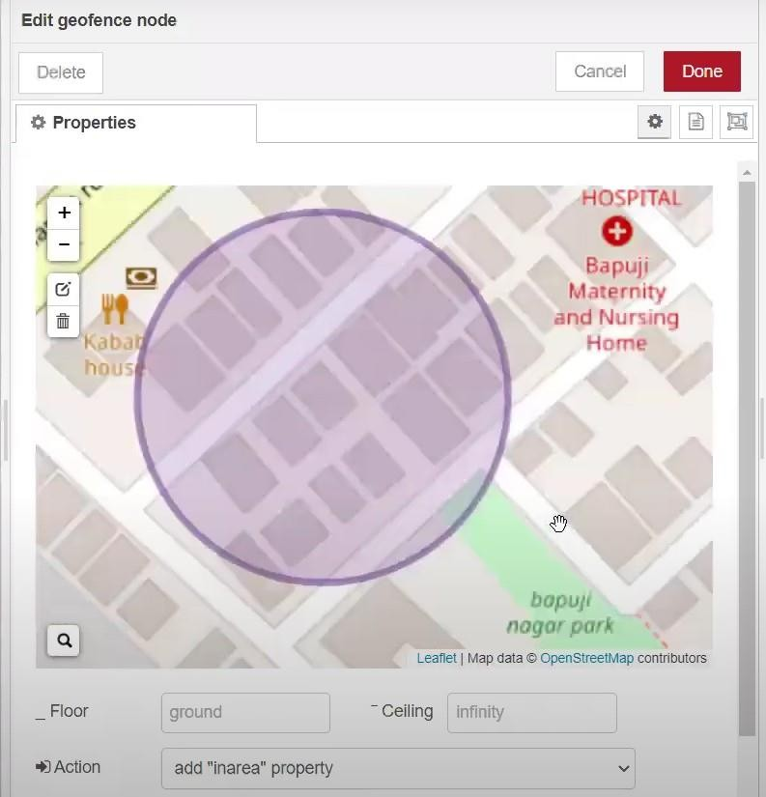Created the GeoFence
* 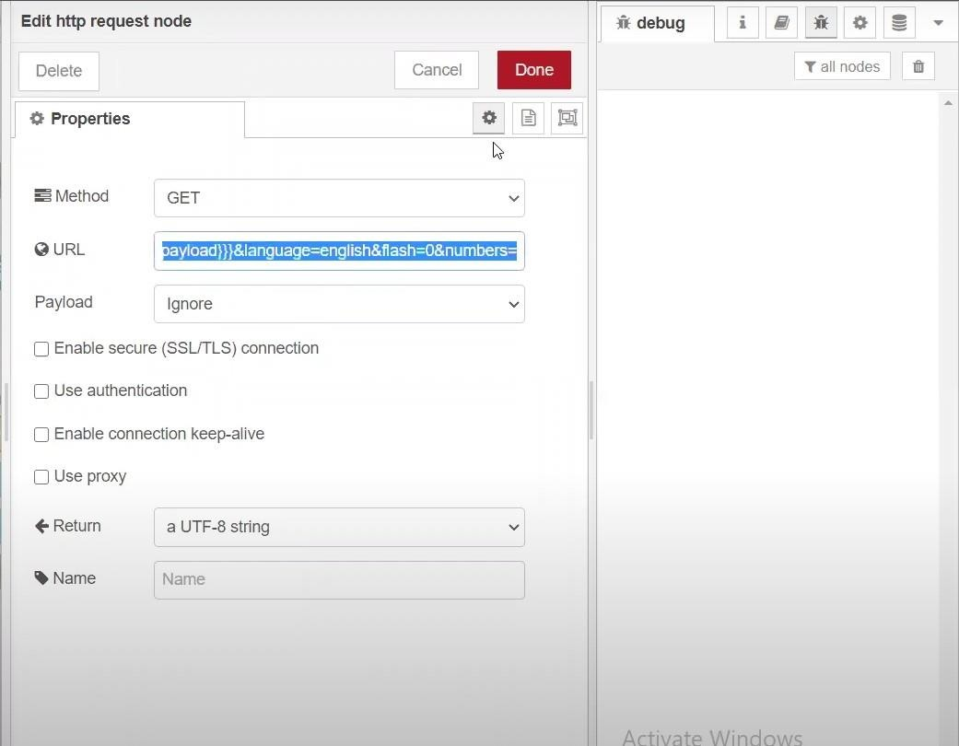Editing the HTTP Request URL
* Located the child

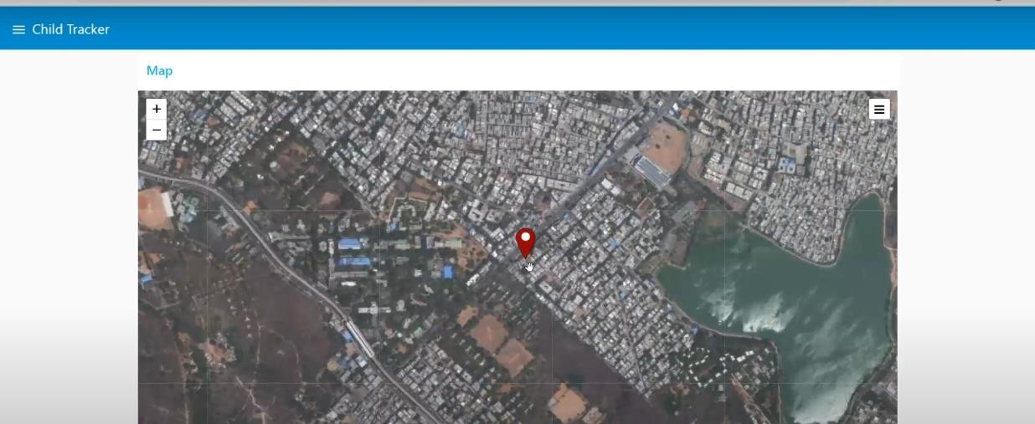

* 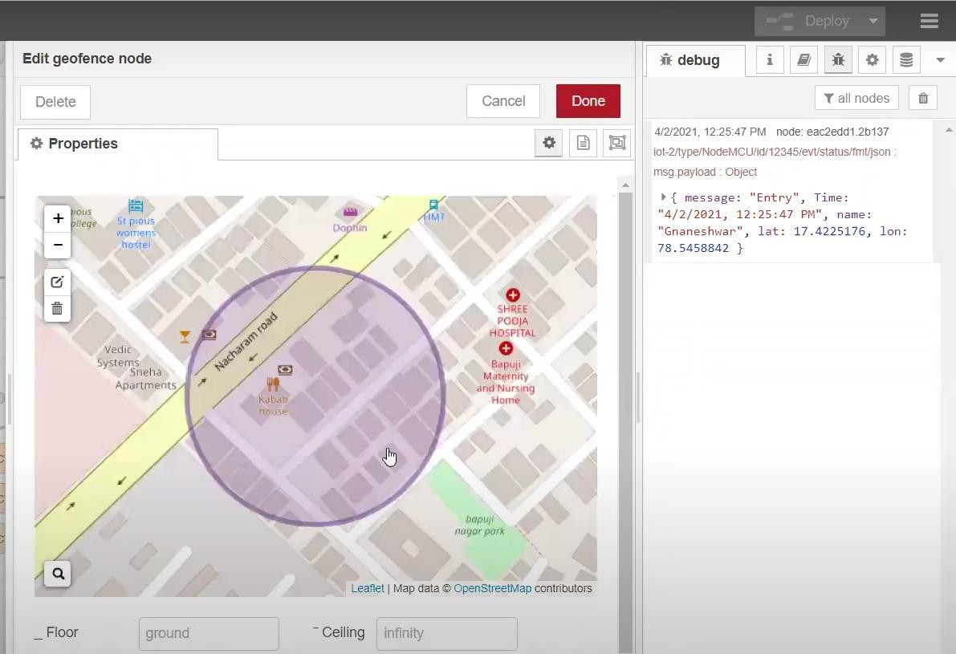Created the geofence node
* 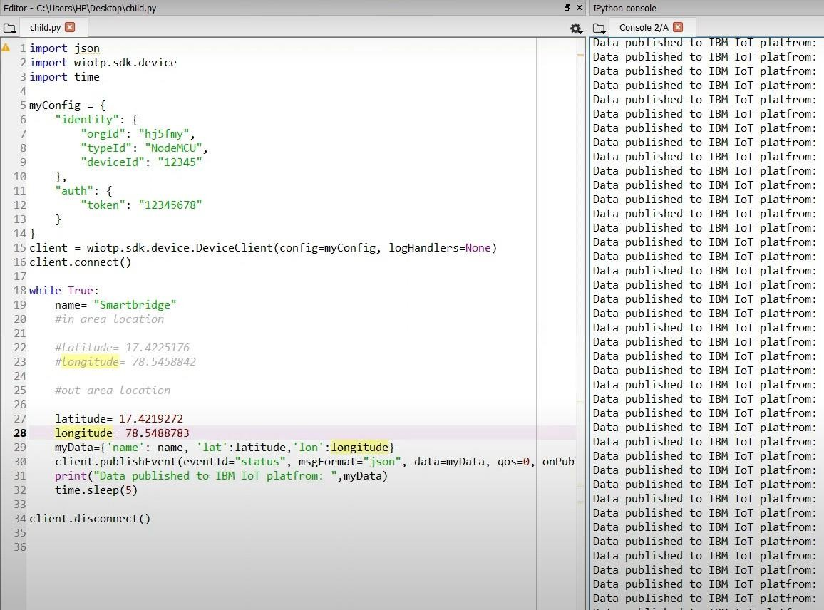Python script sending requests to IBM Cloud
* After running the script, the web UI shows “Person is not in theparticular area”

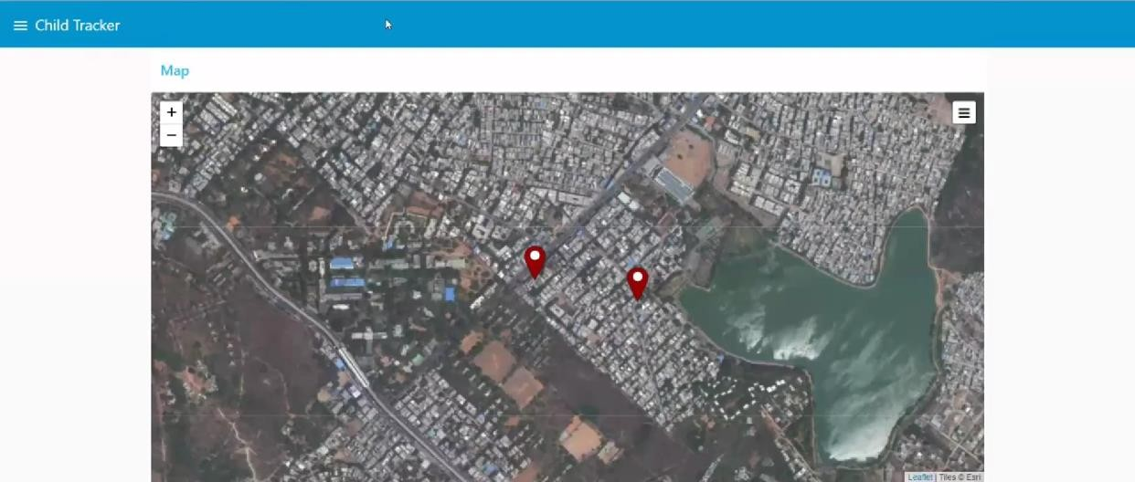

**Result:** Successfully developed a web application using Node-RED